**Algebra 3-4   
1st Semester Final***[Multiplier of 4]*

**Name: _____________________ Block: _________  
 Print**

**Name: _____________________  
 Signature**

**Test Sections Score**

**Chapter 1 Expressions, Equations and Inequalities ______  
  
Chapter 2 Functions, Equations and Graphs ______  
  
Chapter 3 Linear Systems ______  
  
Chapter 4 Quadratic Functions and Equations ______**

**1st Semester Final ______**

**Chapter 1 Expressions, Equations and Inequalities**

Evaluate Using Order of Operations. [L2]

1.) $(8-10)^{2}+7*4-3^{4}$ 1._________________

Solve for the indicated variable. [L2]

2.) $Solve for w: 9+8w-12=7-2w$ 2. $3.) Solve for C: F=\frac{9}{5}C+32$_________________  
  
  
 3._________________  
  
  
4.) $Solve for r: I=Prt$ 4._________________   
  
  
5.) $Solve for h: A=\frac{h}{2}(b_{1}+b_{2})$ 5._________________  
  
  
Solve the Expression for x. [L2]

6.) $4\left(2x-3\right)-6x=10$ 6._________________

Solve the Expression for x. [L3]

7.) $6x^{2}-2=178+x^{2}$ 7._________________

Solve the equation. *Check for extraneous solutions*. [L3]

8.) $3\left|x+5\right|-7=23$ 8._________________

Write an Equation and Solve. [L4]

9. Beth has $537 in her savings account and makes $25 per day babysitting. 9._________________  
Write an equation to represent this situation.   
How many days until she will have $2000 saved?

**Chapter 2 Functions, Equations and Graphs**

Identify the domain and range. Then tell whether the relation is a function.[L2]   
  
1.) {(3, 2), (-2, 5), (1, 0), (-4, 6), (1, -1)} 1. Domain: __________   
 Range __________   
   
 Function? _________   
  
Decided whether the given function is **linear**, then evaluate it for the given value of x. [L2]

2.)  2._________________

Write the Equation in Slope-Intercept Form. [L2]

3.) -3x+2y=7 3._________________

Find the slope of the line through the given points. Then write the equation for the line. [L3]

4.) (6, 8) and (4,2 ) 4._________________

Graph the following equations. [L3]

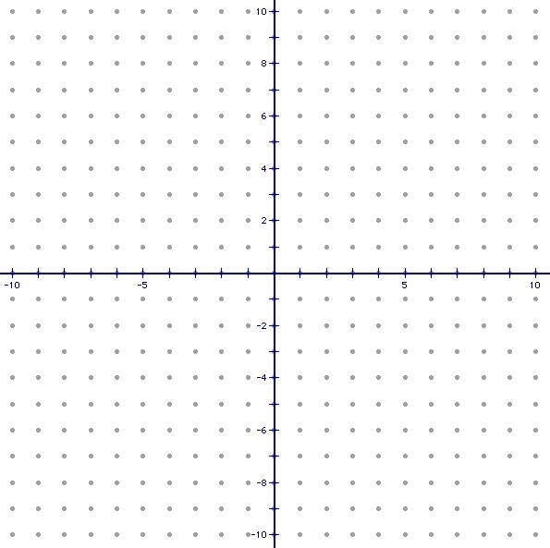5.) 2y +3x = 6 5.

Choose to answer one of the following. [L4]

6.) *Describe a real life situation that would model an event with positive correlation ***and*** write its equation.  
 -or-  
 *Write an absolute value equation with a vertex in the 3rd quadrant that reflects about the x-axis.

**Chapter 3 Linear Systems**

Solve the following systems using any method. [L2]

$1.) 4x+2y=8$ 1.

$y+2x=4$



$2.) 2x-7y=-10$_________________

2.

$3x+2y=10$

_________________

Solve the System. [L3]

3.) $x+2y+3z=6$ 3.

$$y+2z=1$$



$$2y-z=2$$

_________________

Solve the following system. [L4]

4.) A pizza shop makes $1.50 on each small pizza   
and $2.15 on each large pizza. On a typical Friday,   
it sells between 70 and 90 small pizzas and between   
100 and 140 large pizzas. The shop can make no more   
than 210 pizzas each day.   
How many of each size must be sold to maximize profit? 4._________________  
  
**Chapter 4 Quadratic Functions and Equations**

Factor the following. [L2]

$1.) m^{2}-13m-36$ 1. $2.) 12w^{2}-18w^{3}+30$_________________  
  
 2._________________

Graph (Use at least 5 points). [L2] Graph (Use at least 5 points). [L2]



$3.) f\left(x\right)=-2({x-3)}^{2}+4$ $4.) f\left(x\right)=x^{2}+4x+1$

Factor the expression completely. [L2]

5.) 2m2 + 24m + 40 5._________________

Solve the Equations Using Any Method. [L3]

6.) ${ x}^{2}=-15+8x$ 6._________________

7.) ${ 4x}^{2}+17=16x$ 7._________________

Solve the following. [L3]  
8.) A kid throws a ball up in the air and its path is modeled: $h\left(t\right)=-5t^{2}+ 14t + 3$  
where t is the time in seconds and h is the distance from the ground (in feet).   
  
-Find the maximum height of the ball. 8. Max height: _____________  
-How long is the ball in the air? Time in air: _____________  
-From what height was the ball thrown? Initial height: ____________

Solve the following. [L4]

${ 9.) 6x}^{3}-90x={ 12x}^{2} 9.____________________$